MATLAB programs chapter 2

Program 1: A program to find pitch period using method of autocorrelation is given below.
%to find pitch period of the signal
clear all;
fp=fopen('watermark.wav');
fseek(fp,224000,-1);
a=fread(fp,2000);
subplot(2,1,1);plot(a);title('plot of voiced part of a signal');
xlabel('sample no.');ylabel('amplitude');

a=a-128;
for k=1:400,
sum(k)=0;
end
for k=1:400,
for i=1:45,
sum(k)=sum(k)+(a(i)*a(i+k));
sum(k)=sum(k)/45;
end
end
subplot(2,1,2);plot(sum);title('plot of correlation of a signal');
xlabel('sample no.');ylabel('correlation');

A plot of voiced segment and its autocorrelation is shown below.
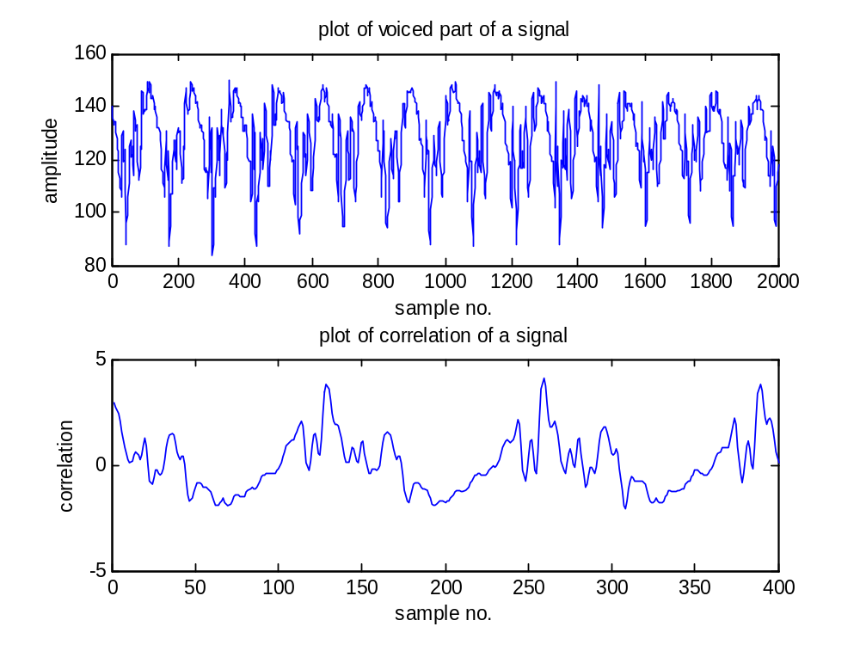

Figure 2.2 plot of voiced speech segment and its autocorrelation.

The correlation output shown in above plot has about 135 samples between successive maxima. Thus 1135 is a pitch period in terms of number of samples.

Program 2: A program to find pitch period using AMDF is given below

%to find pitch period of the signal using AMDF
clear all;
fp=fopen('watermark.wav');
fseek(fp,224000,-1);
a=fread(fp,2000);
subplot(2,1,1);plot(a);title('plot of voiced part of a signal');
xlabel('sample no.');ylabel('amplitude');
for k=1:400,
sum(k)=0;
end
for k=1:400,
for i=1:45,
sum(k)=sum(k)+abs(a(i)-a(i+k));
sum(k)=sum(k)/200;
end
end
subplot(2,1,2);plot(sum);title('plot of Average magnitude difference function of a voiced signal');
xlabel('sample no.');ylabel('AMDF');

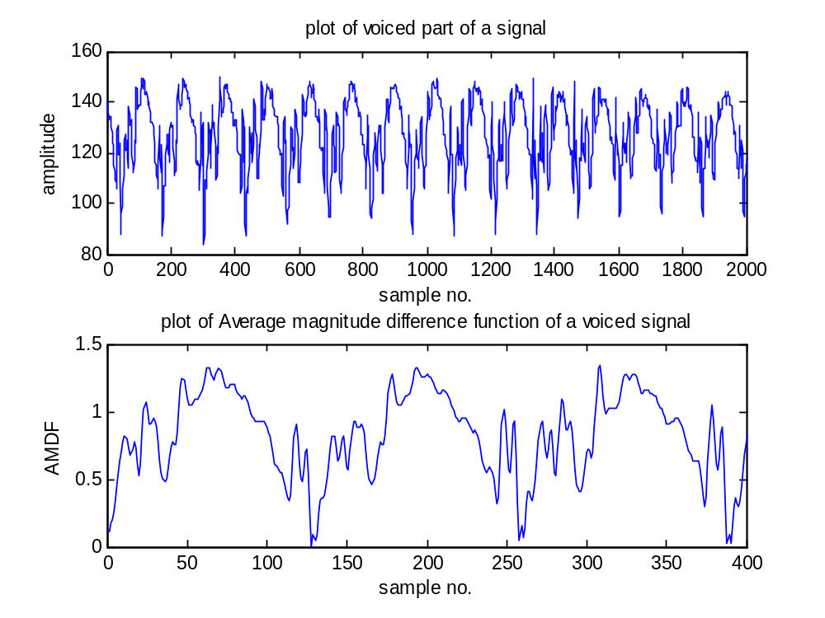
Figure 2.3 plot of voiced part of speech and AMDF

The AMDF output shown in above Figure has about 135 samples between successive minima. Thus pitch period is 135 in terms of number of samples.

Program 3: A program to find pitch for unvoiced segment of ‘’ is given below.
%to find pitch period of the signal
clear all;
fp=fopen('c:/h.wav');
fseek(fp,38444,-1);
a=fread(fp,4000);
a=a-128;
subplot(2,1,1);plot(a);title('plot of unvoiced part of a signal');
xlabel('sample no.');ylabel('amplitude');

for k=1:400,
sum(k)=0;
end
for k=1:400,
for i=1:45,
sum(k)=sum(k)+abs(a(i)-a(i+k));
sum(k)=sum(k)/45;
end
end
subplot(2,1,2);plot(sum);title('plot of AMDF of a signal');
xlabel('sample no.');ylabel('AMDF');

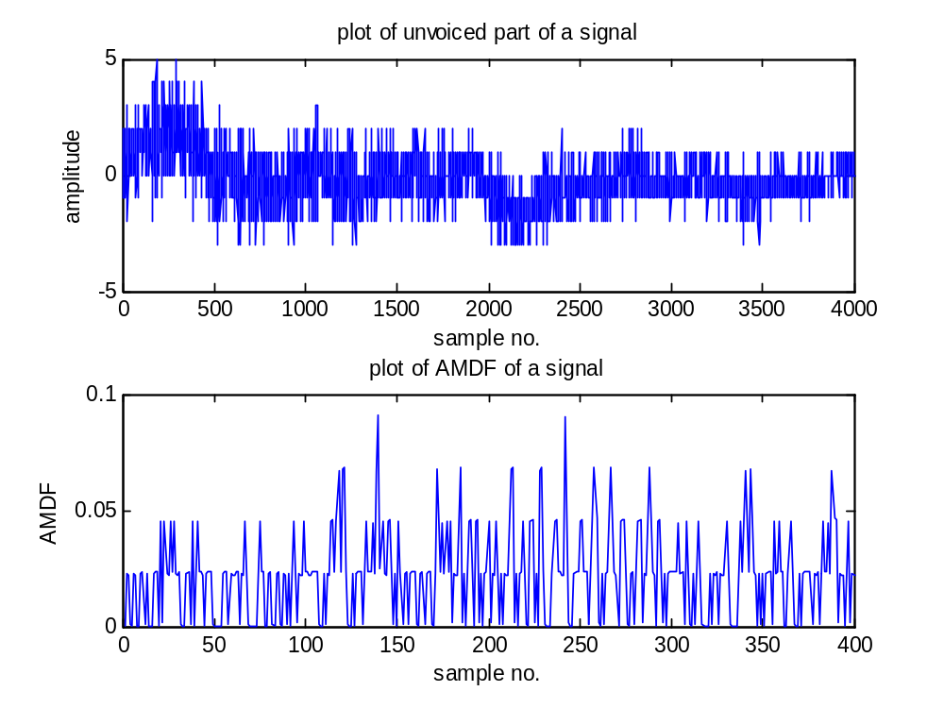
Figure 2.4 Plot of unvoiced segment and its AMDF

The plot for AMDF indicates that there is no periodicity. If we find and track the points where AMDF becomes smallest, we will see that it has quite frequent and random occurrence. This indicates that there is no pitch information present in the signal and the signal is unvoiced.

Program 4: program to find pitch using spectrum is given below
A MATLAB program for spectrum calculation is given below.

%to find pitch period of the signal using spectrum of speech
clear all;
fp=fopen('watermark.wav');
fseek(fp,224000,-1);
a=fread(fp,2048);
subplot(2,1,1);plot(a);title('plot of voiced part of a signal');
xlabel('sample no.');ylabel('amplitude');
a=a-128;
b=abs(fft(a));
f = 22100/2048:22100/2048:22100;
subplot(2,1,2);plot(f,b);title('plot of fft of a signal');
xlabel('frequency');ylabel('amplitude');
disp(b);

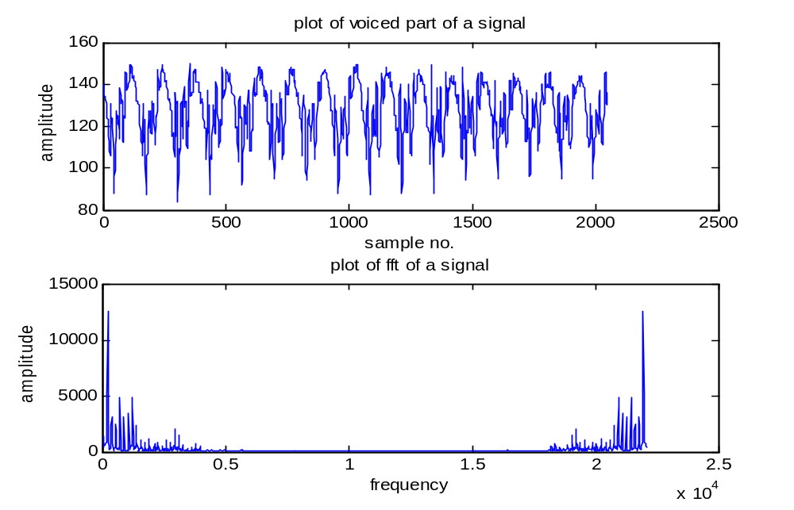
The plot of fft of a signal indicates that the first peak has value equal to 12560 and it occurs at 16th position so fundamental frequency is 10.79*16=172.26Hz. This is a valid pitch frequency value and hence, the speech segment is a voiced speech segment.

Program 5: A MATLAB program to find spectral autocorrelation is given below.

%to find pitch period of the signal using spectral autocorrelation of voiced speech
clear all;
fp=fopen('watermark.wav');
fseek(fp,224000,-1);
a=fread(fp,2048);
subplot(2,1,1);plot(a);title('plot of voiced part of a signal');
xlabel('sample no.');ylabel('amplitude');
a=a-128;
b=abs(fft(a));
f = 22100/2048:22100/2048:22100;
subplot(2,1,2);plot(f,b);title('plot of fft of a signal');
xlabel('frequency');ylabel('amplitude');
for k=1:400,
sum(k)=0;
end
for k=1:400,
for i=1:45,
sum(k)=sum(k)+(b(i)*b(i+k));
sum(k)=sum(k)/52000;
end
end
figure;
plot(sum);title('plot of spectral correlation of voiced signal');
xlabel('sample no.');ylabel('correlation');

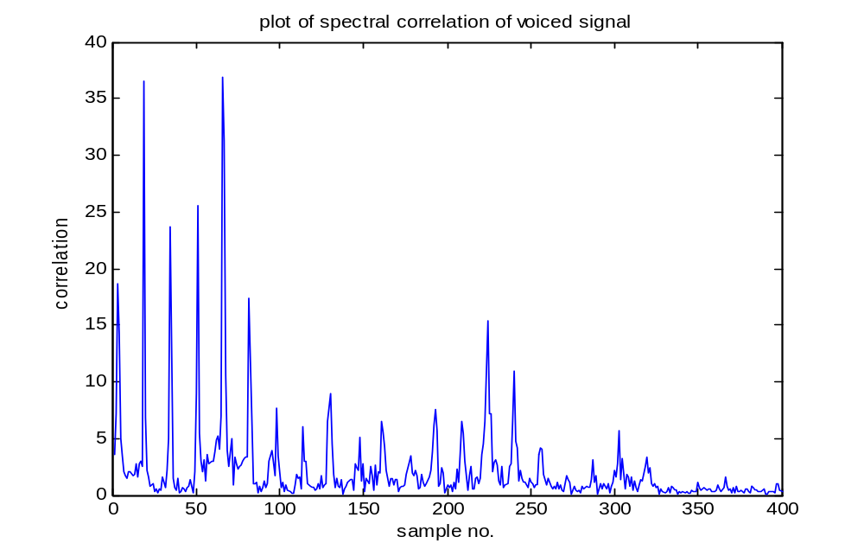
Figure 2.8b Plot of spectral correlation for voiced speech

The spectrum autocorrelation will be highest for frequency interval equal to pitch frequency for voiced segment. This method is called as spectral autocorrelation method. A plot of spectral autocorrelation in Figure shows spectral peaks at regular intervals.

Program 6: A MATLAB program to find pitch frequency using spectrum method for unvoiced segment is given below.

%to find pitch period of the signal using spectrum of unvoiced speech
clear all;
fp=fopen('c:/h.wav');
fseek(fp,38044,-1);
a=fread(fp,2048);
subplot(2,1,1);plot(a);title('plot of unvoiced part of a signal');
xlabel('sample no.');ylabel('amplitude');
a=a-128;
b=abs(fft(a));
c=log(b^2);
f = 22100/2048:22100/2048:22100;
subplot(2,1,2);plot(f,c);title('plot of fft of a signal');
xlabel('frequency');ylabel('amplitude');
disp(b);
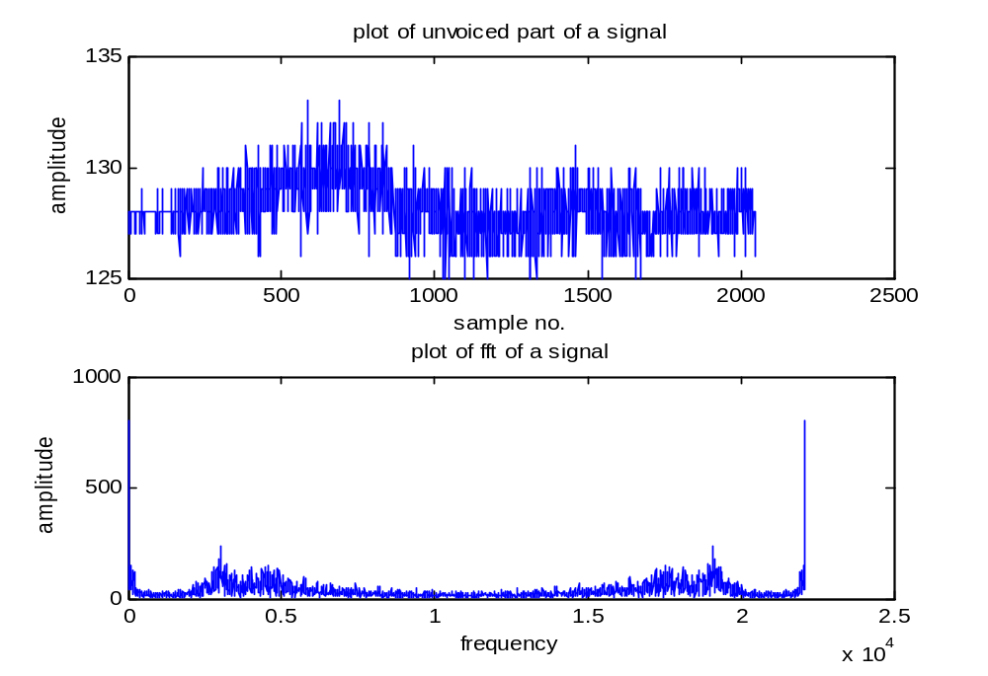
Figure 2.9a Plot of unvoiced signal and its FFT

Program 7: A MATLAB program for calculation of spectral autocorrelation can be written on same lines. We have to append following lines to the program above. We can take V/UV decision based on spectral similarity.

for k=1:400,
sum(k)=0;
end
for k=1:400,
for i=1:45,
sum(k)=sum(k)+(b(i)*b(i+k));
sum(k)=sum(k)/52000;
end
end
figure;
plot(sum);title('plot of spectral correlation of unvoiced signal');
xlabel('sample no.');ylabel('correlation');

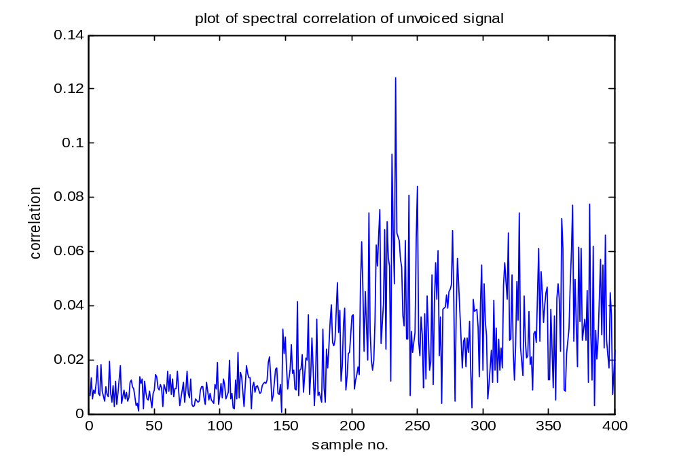
Program 8: We give below the MATLAB program listing for finding cepstrum of speech segment is given below..
%to find pitch period of the voiced signal using capstrum of speech signal
clear all;
fp=fopen('watermark.wav');
fseek(fp,224000,-1);
a=fread(fp,2048);
a=a-128;
subplot(2,1,1);plot(a);title('plot of voiced part of a signal');
xlabel('sample no.');ylabel('amplitude');
%2048 samples of the voiced signal are displayed
a1=window(@Hamming,2048);
subplot(2,1,2);plot(a1);title('plot of Hamming window signal');
xlabel('sample no.');ylabel('amplitude');
for i=1:2048,
a11(i)=a(i)*a1(i);
end
figure;
subplot(2,1,1);plot(a11);title('plot of windowed voiced part of a signal');
xlabel('sample no.');ylabel('amplitude');
%the signal is passed via Hamming window and displayed.
b=abs(fft(a11));
f = 22100/2048:22100/2048:22100;
subplot(2,1,2);plot(f,b);title('plot of fft of windowed signal');
xlabel('frequency');ylabel('amplitude');
c=log(b);
figure;
for i=1:1024,
d(i)=c(i);
end
f = 22100/2048:22100/2048:11050;
subplot(2,1,1);plot(f,d);
title('log spectrum of windowed voiced speech signal');
xlabel('Frequency in Hz');ylabel('amplitude in dB');
e=abs(ifft(c));
subplot(2,1,2);plot(e);
title('cepstrum of voiced speech signal');
xlabel('Quefrency');ylabel('amplitude in dB');
for i=1:80,
h(i)=0;
end
for i=81:1967,
h(i)=e(i);
end
for i=1968:2048,
h(i)=0;
end
% for i=1:1024,
% h(i)=g(i);
% end
figure;
subplot(2,1,1);plot(e); title('cepstrum of voiced speech signal after passing through window');
xlabel('Quefrency');ylabel('amplitude in dB');

g=abs(fft(h));
for i=1:1024,
k(i)=g(i);
end
f = 22100/2048:22100/2048:11050;
subplot(2,1,2);
plot(f,k);title('spectrum of voiced speech cepstral windowed');
xlabel('frequency');ylabel('amplitude in dB');
disp(k);

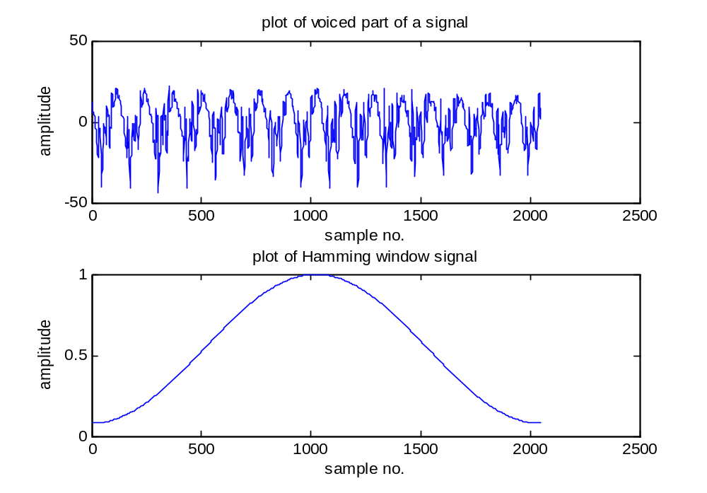
Figure 2.11 Plot of 2048 samples of voiced speech and Hamming window function

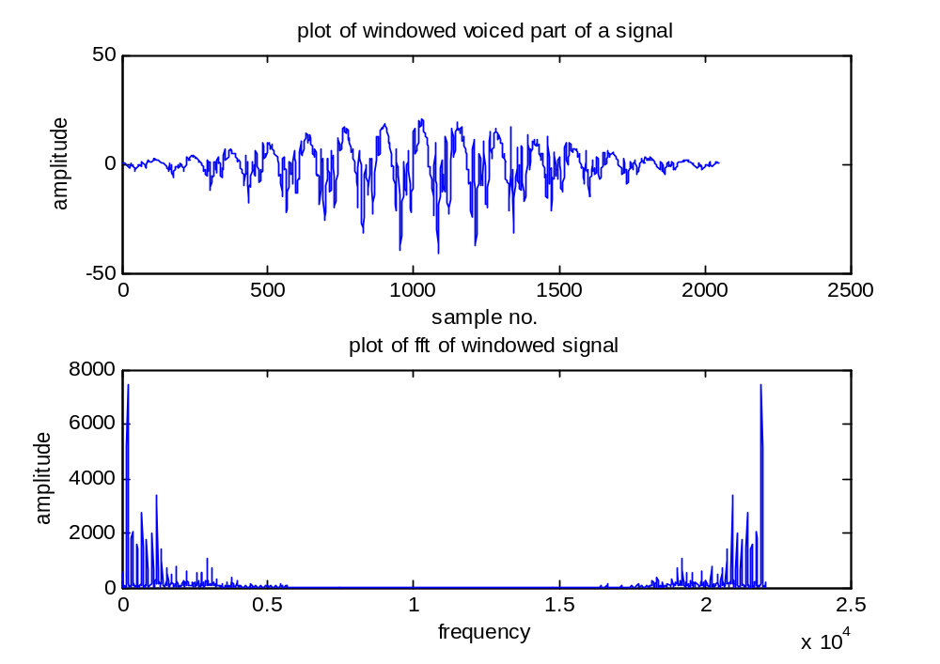
Figure 2.12 Plot of 2048 samples of Hamming windowed voiced speech and its FFT

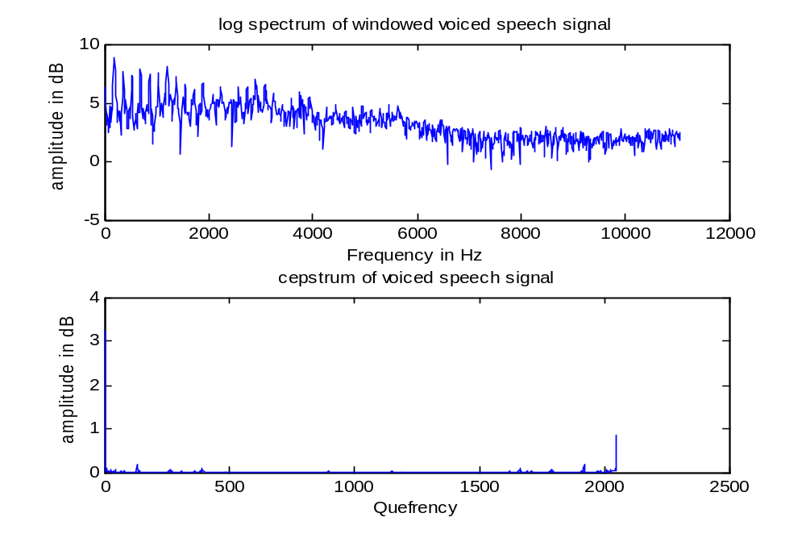
Figure 2.13 plot of log spectrum of 2048 samples of voiced speech and its Cepstrum

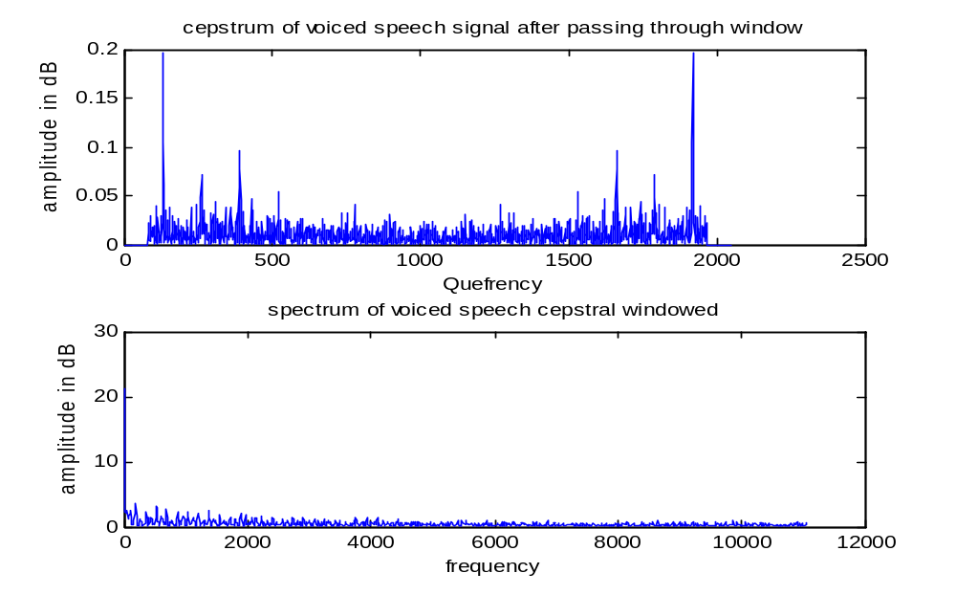
Figure 2.14 plot of windowed cepstrum of 2048 samples of voiced speech and its FFT

The final output plot shows rapid variations corresponding to the fundamental frequency. We can now track the first peak. There is no chance that it will overlap with the first formant now as we have removed the cluster near the origin corresponding to the vocal tract information.

Program 9: program to find cepstrum of unvoiced segment is given below.
%to find pitch period of the voiced signal using capstrum of speech signal
clear all;
fp=fopen('watermark.wav');
fseek(fp,23044,-1);
a=fread(fp,2048);
a=a-128;
subplot(2,1,1);plot(a);title('plot of unvoiced part of a signal');
xlabel('sample no.');ylabel('amplitude');
%2048 samples of the voiced signal are displayed

a1=window(@Hamming,2048);
subplot(2,1,2);plot(a1);title('plot of Hamming window signal');
xlabel('sample no.');ylabel('amplitude');
for i=1:2048,
a11(i)=a(i)*a1(i);
end
figure;
subplot(2,1,1);
plot(a11);title('plot of windowed unvoiced part of a signal');
xlabel('sample no.');ylabel('amplitude');
%the signal is passed via Hamming window and displayed.
b=abs(fft(a11));
f = 22100/2048:22100/2048:22100;
subplot(2,1,2);plot(f,b);title('plot of fft of windowed signal');
xlabel('frequency');ylabel('amplitude');
c=log(b);
figure;
for i=1:1024,
d(i)=c(i);
end
f = 22100/2048:22100/2048:11050;
subplot(2,1,1);plot(f,d);
title('log spectrum of windowed unvoiced speech signal');
xlabel('Frequency in Hz');ylabel('amplitude in dB');
e=abs(ifft(c));

subplot(2,1,2);plot(e);
title('cepstrum of unvoiced speech signal');
xlabel('Quefrency');ylabel('amplitude in dB');
for i=1:80,
h(i)=0;
end
for i=81:1967,
h(i)=e(i);
end
for i=1968:2048,
h(i)=0;
end
figure;
subplot(2,1,1);plot(h); title('cepstrum of unvoiced speech signal after passing through window');
xlabel('Quefrency');ylabel('amplitude in dB');

g=abs(fft(h));

for i=1:1024,
k(i)=g(i);
end
f = 22100/2048:22100/2048:11050;
subplot(2,1,2);
plot(f,k);title('spectrum of unvoiced speech cepstral windowed');
xlabel('frequency');ylabel('amplitude in dB');
disp(k);

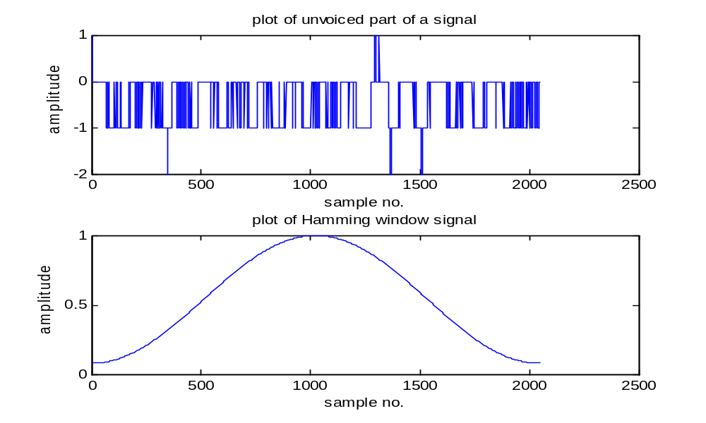
Figure 2.15 Plot of unvoiced segment and a plot of window function.
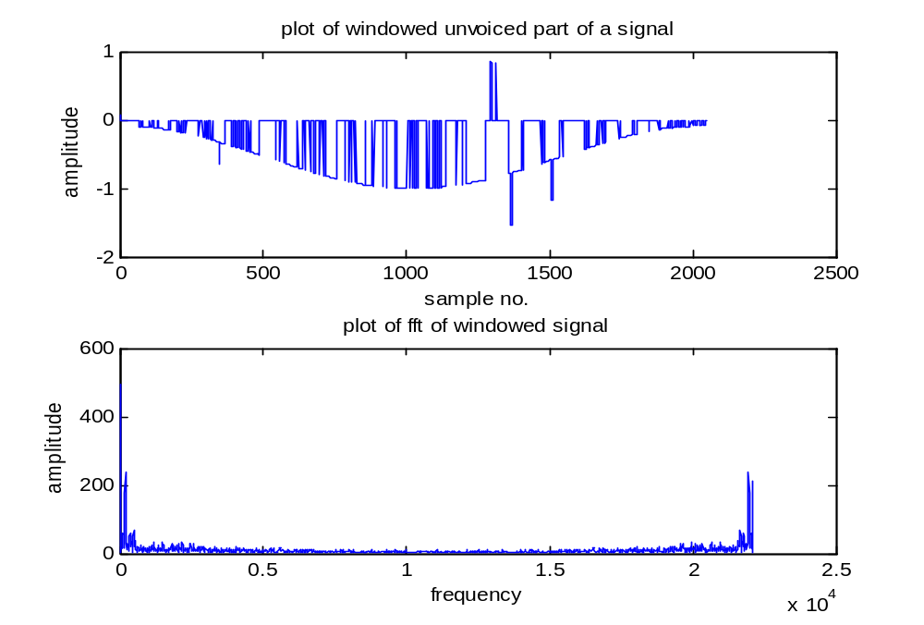
Figure 2.16 Plot of windowed unvoiced utterance and its FFT

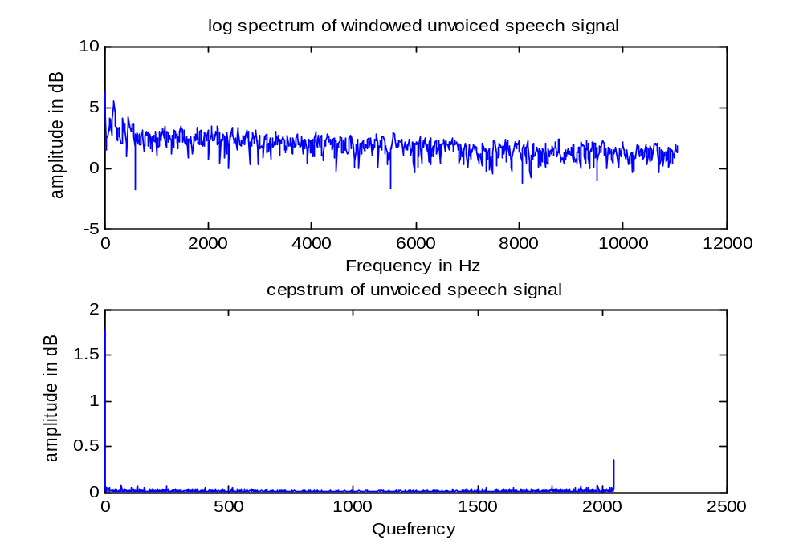
Figure 2.17 Plot of log spectrum of unvoiced segment and its cepstrum.
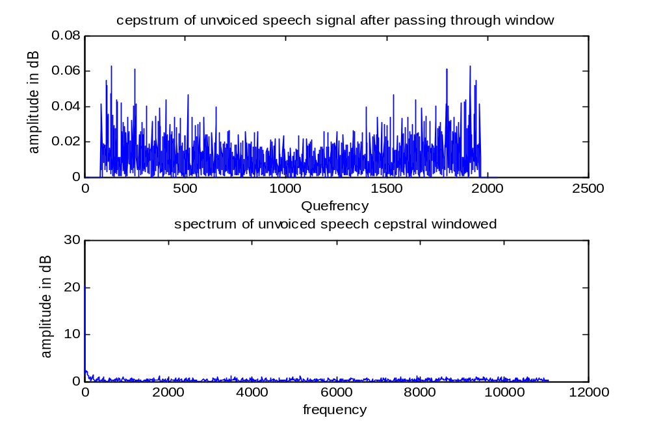
Figure 2,18 Plot of windowed cepstrum and its FFT

The final output plot of spectrum shows random variations.

Program 10: The MATLAB program for evaluation of formants using cepstrum is given below.
%to find formants from the voiced signal using capsrum of speech signal
clear all;
fp=fopen('watermark.wav');
fseek(fp,224000,-1);
a=fread(fp,2048);
a=a-128;
subplot(2,1,1);plot(a);title('plot of voiced part of a signal');
xlabel('sample no.');ylabel('amplitude');
%2048 samples of the voiced signal are displayed

a1=window(@Hamming,2048);
subplot(2,1,2);plot(a1);title('plot of Hamming window signal');
xlabel('sample no.');ylabel('amplitude');
for i=1:2048,
a11(i)=a(i)*a1(i);
end
figure;
subplot(2,1,1);
plot(a11);title('plot of windowed voiced part of a signal');
xlabel('sample no.');ylabel('amplitude');
%the signal is passed via Hamming window and displayed.
b=abs(fft(a11));
f = 22100/2048:22100/2048:22100;
subplot(2,1,2);plot(f,b);title('plot of fft of windowed signal');
xlabel('frequency');ylabel('amplitude');
c=log(b);
figure;
for i=1:1024,
d(i)=c(i);
end
f = 22100/2048:22100/2048:11050;
subplot(2,1,1);plot(f,d);
title('log spectrum of windowed voiced speech signal');
xlabel('Frequency in Hz');ylabel('amplitude in dB');
e=abs(ifft(c));

subplot(2,1,2);plot(e);
title('cepstrum of voiced speech signal');
xlabel('Quefrency');ylabel('amplitude in dB');
for i=1:40,
h(i)=e(i);
end
for i=41:2007,
h(i)=0;
end
for i=2008:2048,
h(i)=e(i);
end
figure;
subplot(2,1,1);plot(h); title('cepstrum of voiced speech signal after passing through window');
xlabel('Quefrency');ylabel('amplitude in dB');
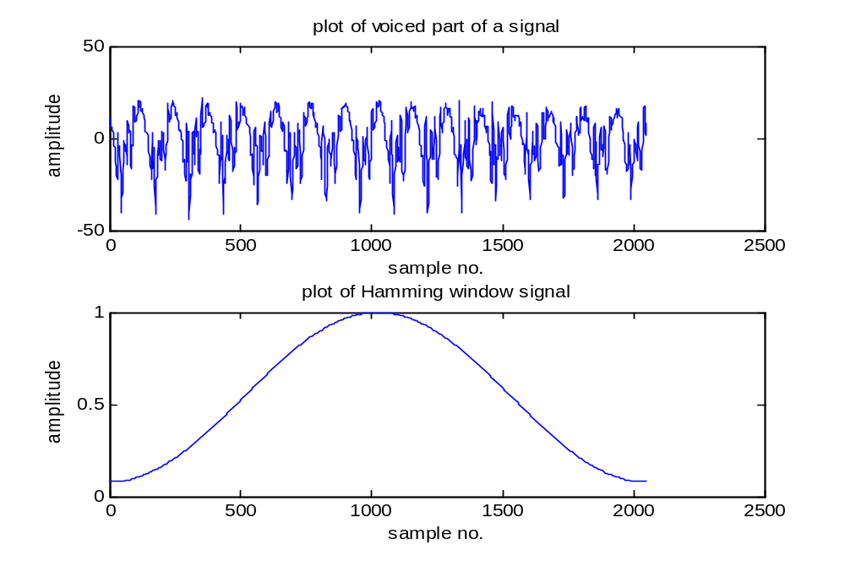
Figure 2.20 plot of voiced speech segment and Hamming window.

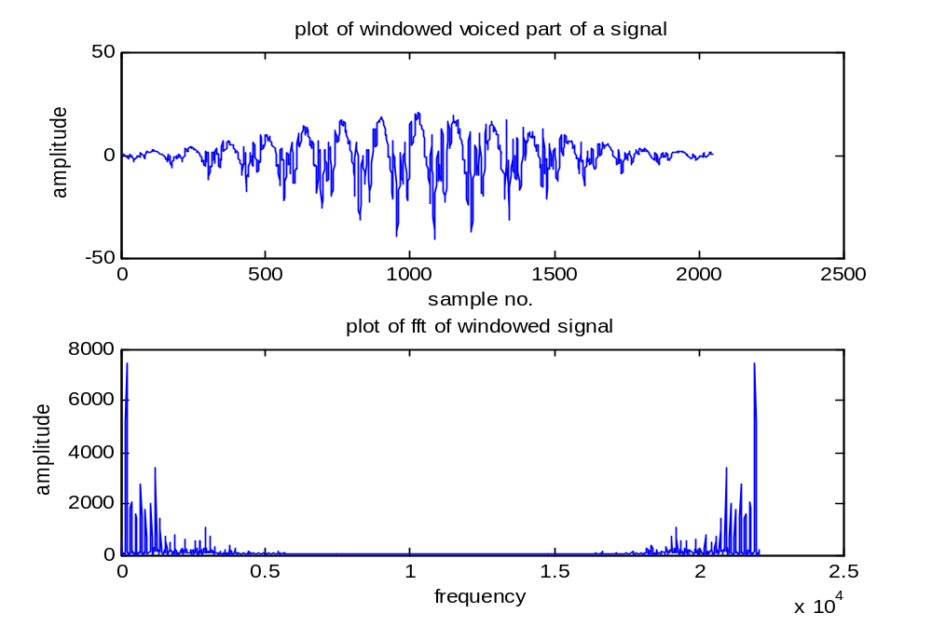
Figure 2.21 plot of windowed voiced speech segment and FFT.

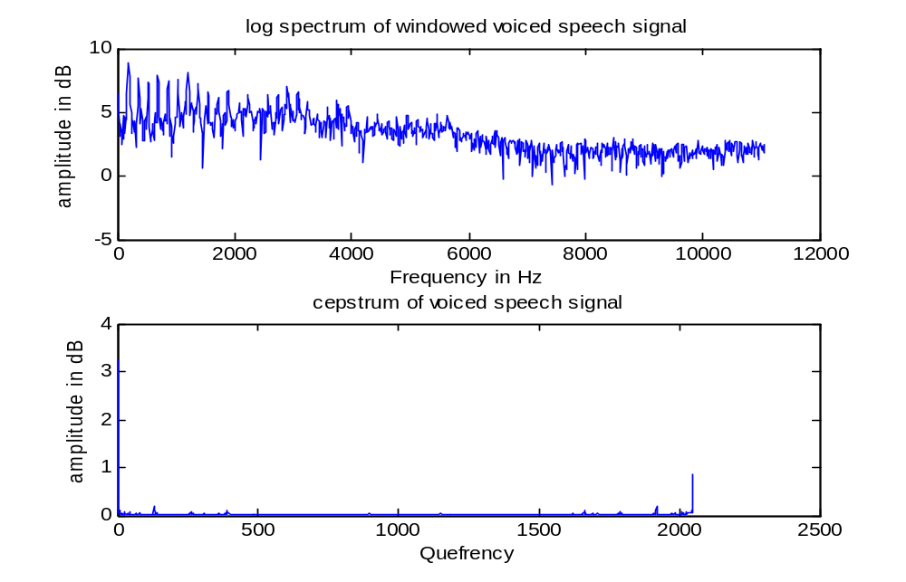
Figure 2.22 plot of log spectrum of voiced speech segment and cepstrum.

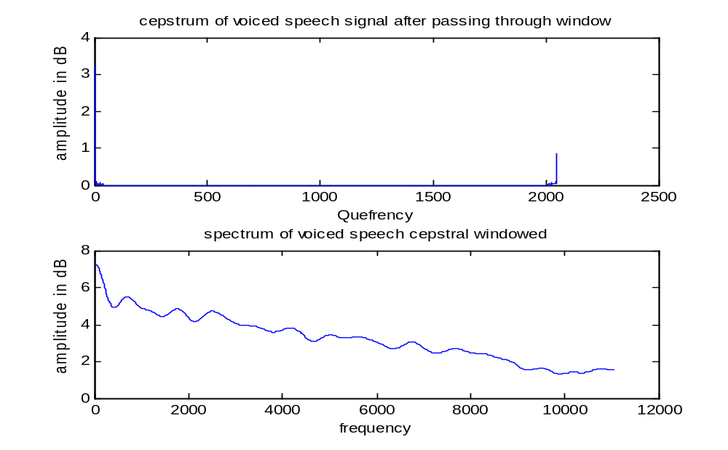
Figure 2.23 plot of windowed cepstrum and FFT of cepstrum.

The final output plot of FFT of windowed cepstrum shows a slowly varying envelope corresponding to the formants. We can now track the peaks. The first four peaks corresponding to the first four formants can be tracked by observation and we see that they are near 800 Hz, 1900 Hz, 2400 Hz and 4000 Hz.

Program 11: Evaluation of formants for unvoiced segment.

%to find formants from the unvoiced signal using capsrum of speech signal
clear all;
fp=fopen('watermark.wav');
fseek(fp,23044,-1);
a=fread(fp,2048);
a=a-128;
subplot(2,1,1);plot(a);title('plot of unvoiced part of a signal');
xlabel('sample no.');ylabel('amplitude');
%2048 samples of the voiced signal are displayed

a1=window(@Hamming,2048);
subplot(2,1,2);plot(a1);title('plot of Hamming window signal');
xlabel('sample no.');ylabel('amplitude');
for i=1:2048,
a11(i)=a(i)*a1(i);
end
figure;
subplot(2,1,1);
plot(a11);title('plot of windowed unvoiced part of a signal');
xlabel('sample no.');ylabel('amplitude');
%the signal is passed via Hamming window and displayed.
b=abs(fft(a11));
f = 22100/2048:22100/2048:22100;
subplot(2,1,2);plot(f,b);title('plot of fft of windowed signal');
xlabel('frequency');ylabel('amplitude');
c=log(b);
figure;
for i=1:1024,
d(i)=c(i);
end
f = 22100/2048:22100/2048:11050;
subplot(2,1,1);plot(f,d);
title('log spectrum of windowed unvoiced speech signal');
xlabel('Frequency in Hz');ylabel('amplitude in dB');
e=abs(ifft(c));

subplot(2,1,2);plot(e);
title('cepstrum of unvoiced speech signal');
xlabel('Quefrency');ylabel('amplitude in dB');
for i=1:40,
h(i)=e(i);
end
for i=41:2007,
h(i)=0;
end
for i=2008:2048,
h(i)=e(i);
end
figure;
subplot(2,1,1);plot(h); title('cepstrum of voiced speech signal after passing through window');
xlabel('Quefrency');ylabel('amplitude in dB');

g=abs(fft(h));

for i=1:1024,
k(i)=g(i);
end
f = 22100/2048:22100/2048:11050;
subplot(2,1,2);
plot(f,k);title('spectrum of voiced speech cepstral windowed');
xlabel('frequency');ylabel('amplitude in dB');
disp(k);

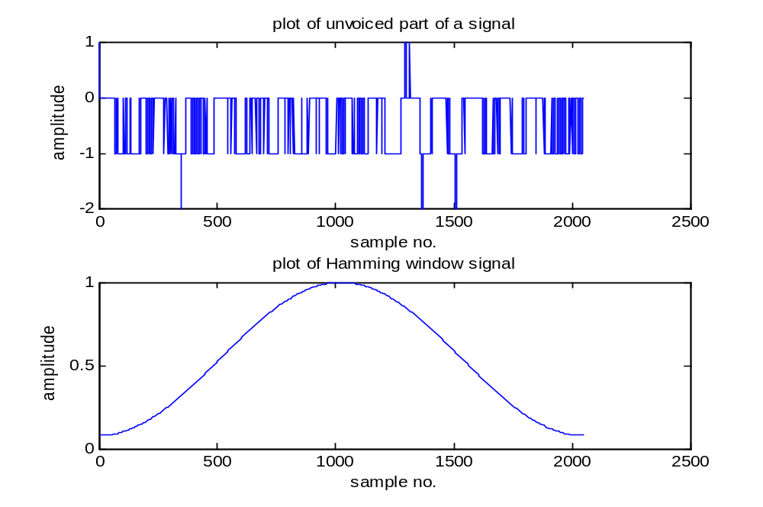
Figure 2.24 Plot of unvoiced segment and Hamming window.
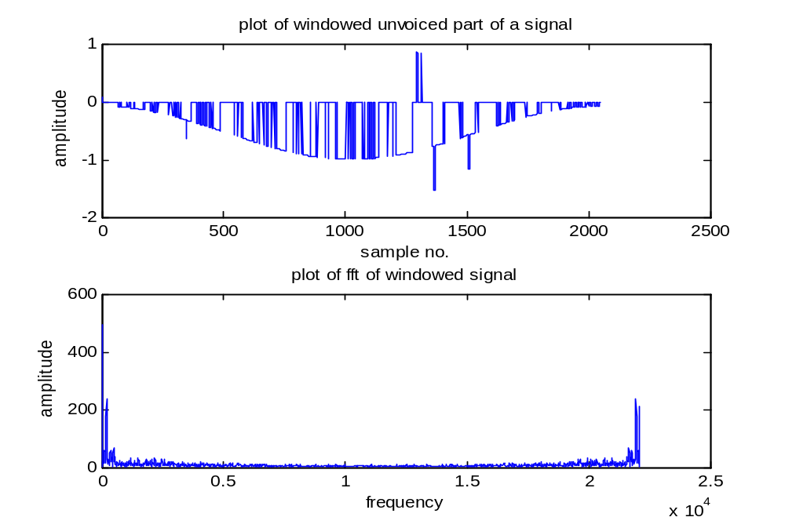
Figure 2.25 Plot of windowed unvoiced segment and its FFT.
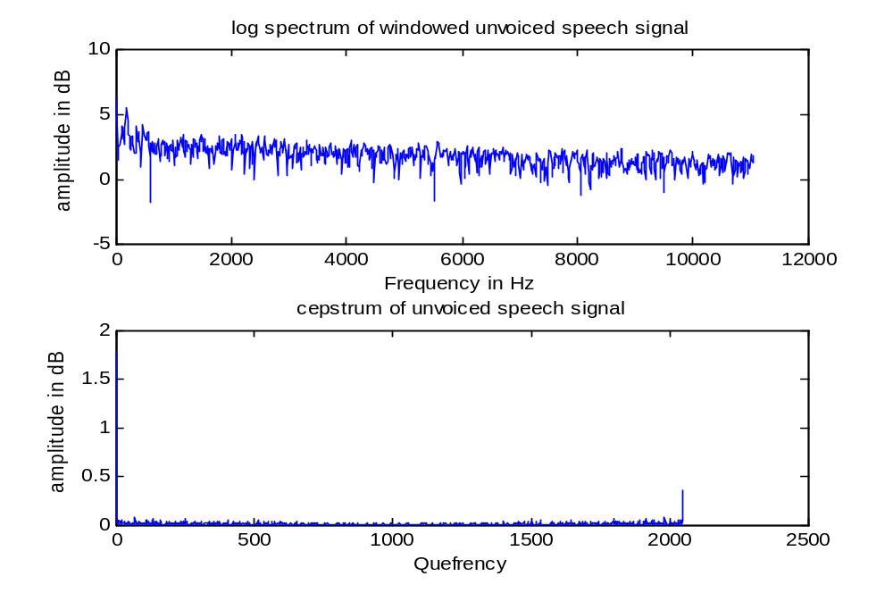
Figure 2.26 Plot of log spectrum of windowed unvoiced segment and cepstrum

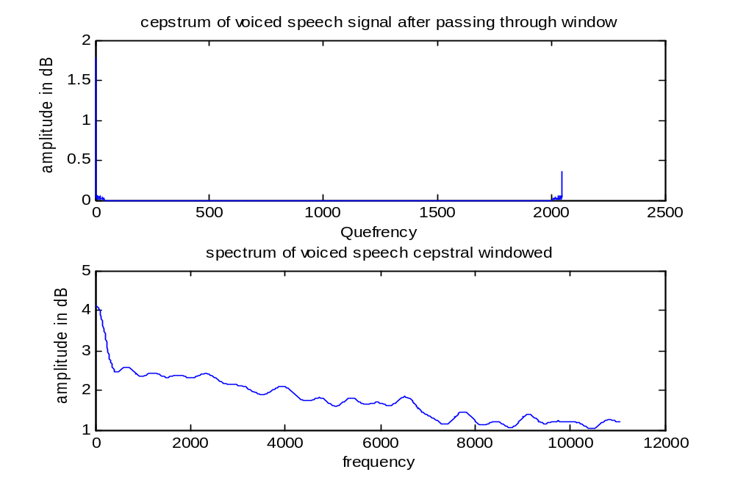
Figure 2.27 Plot of windowed cepstrum and its FFT

The first four peaks corresponding to the first four formants can be tracked by observation and we see that they are near 800 Hz, 1200 Hz, 1900 Hz and 2400 Hz.

Program 12: program to find formant using log spectrum
%to find formants from the voiced signal using log spectrum of speech signal
clear all;
fp=fopen('watermark.wav');
fseek(fp,224000,-1);
a=fread(fp,2048);
a=a-128;
subplot(2,1,1);plot(a);title('plot of voiced part of a signal');
xlabel('sample no.');ylabel('amplitude');
%2048 samples of the voiced signal are displayed

a1=window(@Hamming,2048);
for i=1:2048,
a11(i)=a(i)*a1(i);
end

subplot(2,1,2);
plot(a11);title('plot of windowed voiced part of a signal');
xlabel('sample no.');ylabel('amplitude');
figure;
%the signal is passed via Hamming window and displayed.
b=abs(fft(a11));
f = 22100/2048:22100/2048:22100;
subplot(2,1,1);plot(f,b);title('plot of fft of windowed signal');
xlabel('frequency');ylabel('amplitude');
c=log(b);

for i=1:1024,
d(i)=c(i);
end
f = 22100/2048:22100/2048:11050;
subplot(2,1,2);plot(f,d);
title('log spectrum of windowed voiced speech signal');
xlabel('Frequency in Hz');ylabel('amplitude in dB');
e=abs(ifft(c));
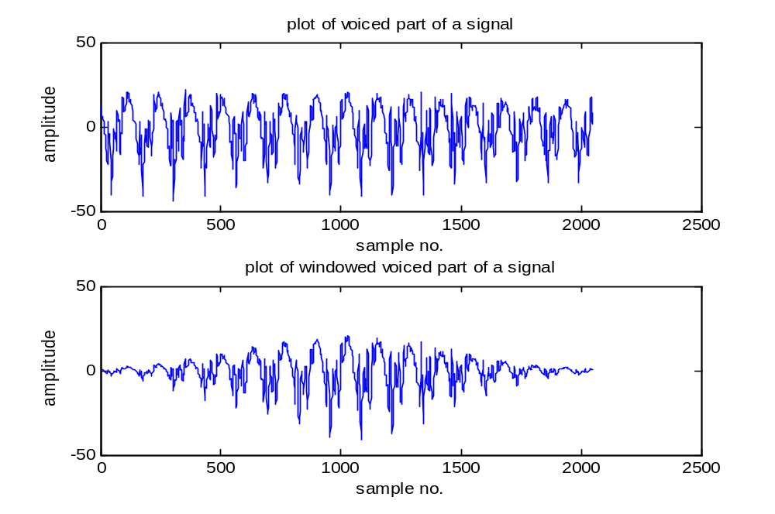
Figure 2,28 Plot of voiced speech and windowed signal.
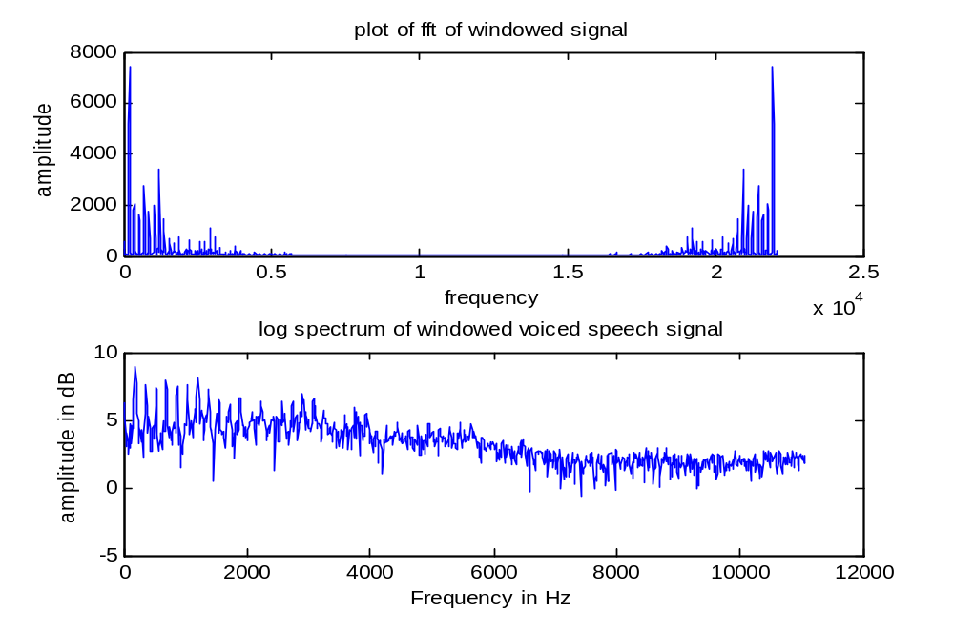
Figure 2.29 Plot of FFT of windowed signal and log spectrum

The final output plot of log spectrum shows a slowly varying envelope corresponding to the formants. We can now track the peaks. The first four peaks corresponding to the first four formants can be tracked by observation and we see that they are near 800 Hz, 1200 Hz, 1900 Hz, 3000 Hz and 3800 Hz. The very first peak at about 200 Hz is corresponding to the fundamental frequency.

Program 13: program to find formants using log spectrum for unvoiced segment
%to find formants from the unvoiced signal using clog spectrum of speech signal
clear all;
fp=fopen('watermark.wav');
fseek(fp,23044,-1);
a=fread(fp,2048);
a=a-128;
subplot(2,1,1);plot(a);title('plot of unvoiced part of a signal');
xlabel('sample no.');ylabel('amplitude');
%2048 samples of the voiced signal are displayeds
a1=window(@Hamming,2048);
for i=1:2048,
a11(i)=a(i)*a1(i);
end

subplot(2,1,2);
plot(a11);title('plot of windowed unvoiced part of a signal');
xlabel('sample no.');ylabel('amplitude');
figure;
%the signal is passed via Hamming window and displayed.
b=abs(fft(a11));
f = 22100/2048:22100/2048:22100;
subplot(2,1,1);plot(f,b);title('plot of fft of windowed signal');
xlabel('frequency');ylabel('amplitude');
c=log(b);

for i=1:1024,
d(i)=c(i);
end
f = 22100/2048:22100/2048:11050;
subplot(2,1,2);plot(f,d);
title('log spectrum of windowed unvoiced speech signal');
xlabel('Frequency in Hz');ylabel('amplitude in dB');
e=abs(ifft(c));

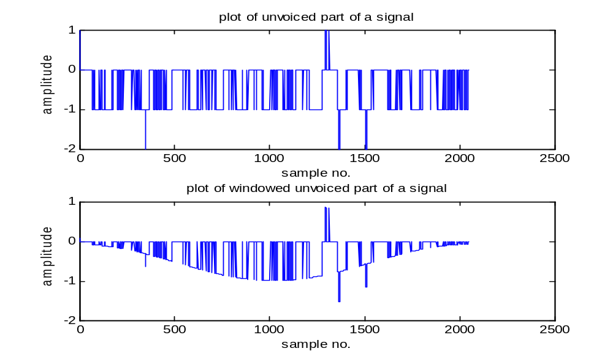
Figure 2.30 Plot of unvoiced segment and windowed segment
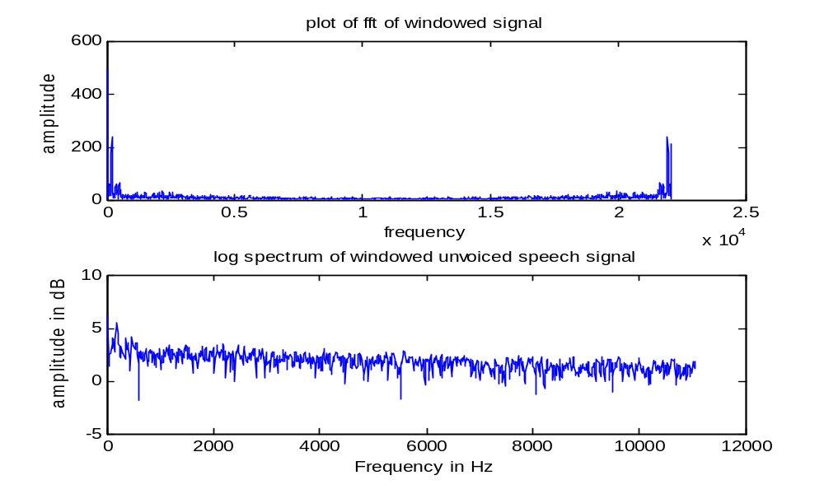
Figure 2.31 Plot of FFT of windowed speech and log spectrum

The rapid random variations correspond to the turbulence as excitation and slowly varying envelope corresponds to the vocal tract parameters. We can now track the peaks. The first four peaks corresponding to the first four formants can be tracked by observation and we see that they are near 800 Hz, 1200 Hz, 2200 Hz and 2400 Hz.

Program 13: Program to find formants using power spectrum estimate using Welch method and method of periodograms for voiced segment

%to find formants from the voiced signal using power spectral estimation of speech signal using Welch method.

clear all;
fp=fopen('watermark.wav');
fseek(fp,224000,-1);
a=fread(fp,2048);
a=a-128;
subplot(2,1,1);plot(a);title('plot of voiced part of a signal');
xlabel('sample no.');ylabel('amplitude');
%2048 samples of the voiced signal are displayed

subplot(2,1,2);

Fs = 22100; t = 0:1/Fs:.296;
h=spectrum.welch
d = psd(h,a11,'Fs',Fs);
%Calculate the Power spectrum estimate using Welch method
plot(d);

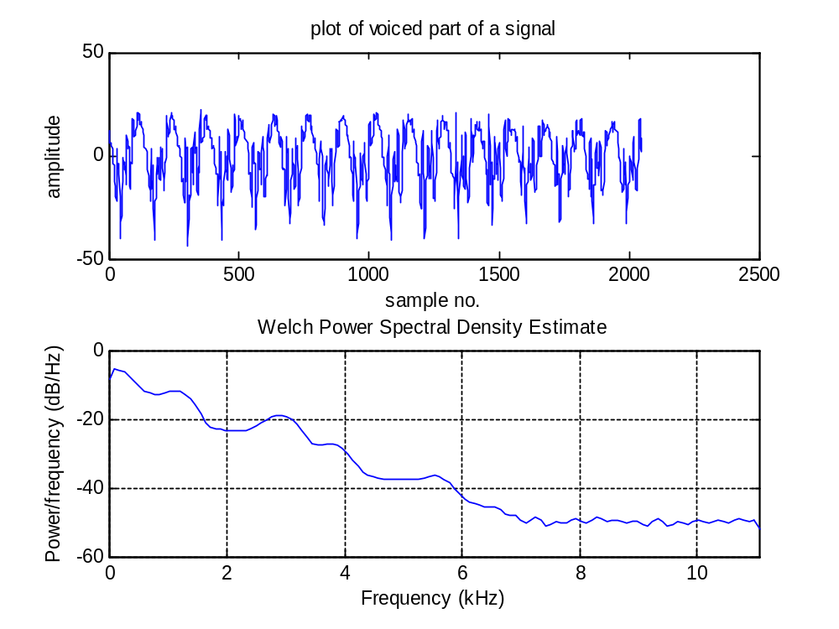
Figure 2.32 plot of signal and its power spectrum estimation using Welch method

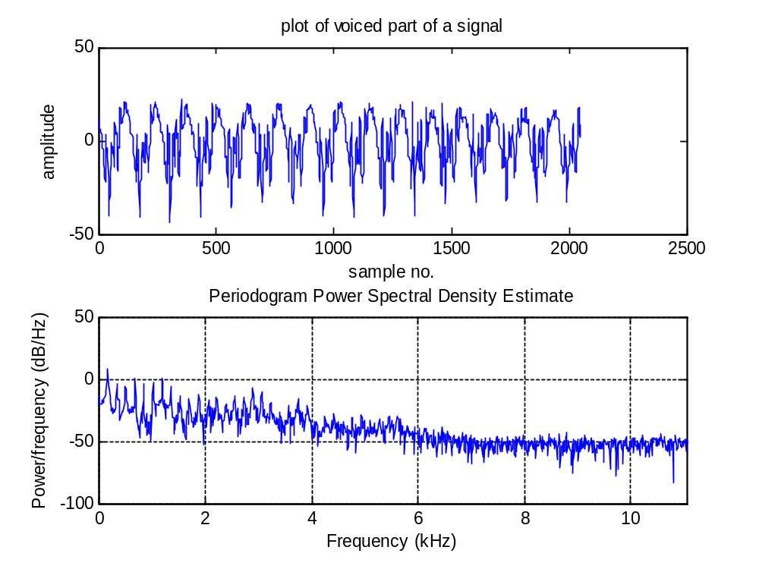
Figure 2.33 plot of signal and its power spectrum estimate using method of periodiogram.

Interpretation of the results: Welch method used in the program uses segment size of 64 allowing frequency resolution of 22100/64 i.e 345.31 Hz. The frequency points plotted are for 345.31 Hz, 690.62Hz, 1035.93 Hz, 1381.24 Hz, 1726.55 Hz, 2071.66 Hz, 2417.11 Hz, 2762.48 Hz, 3107.79 Hz etc. the peaks for power spectrum density using Welch method seem to occur at 1300 Hz, 3000 Hz and 3800 Hz. The peaks at 800 Hz and 1900 Hz are lost, we can say that the peaks near the frequency points resolved by the window are detected and other peaks are lost.

Program 14: Program to find formants using power spectrum estimate using Welch method and method of periodograms for unvoiced segment
%to find formants from the unvoiced signal using capstrum of speech signal
clear all;
fp=fopen('watermark.wav');
fseek(fp,23044,-1);
a=fread(fp,2048);
a=a-128;
subplot(2,1,1);plot(a);title('plot of unvoiced part of a signal');
xlabel('sample no.');ylabel('amplitude');
%2048 samples of the voiced signal are displayed

a1=window(@Hamming,2048);
for i=1:2048,
a11(i)=a(i)*a1(i);
end

subplot(2,1,2);
plot(a11);title('plot of windowed voiced part of a signal');
xlabel('sample no.');ylabel('amplitude');

%the signal is passed via Hamming window and displayed.
Fs = 22100; t = 0:1/Fs:.296;
h=spectrum.welch
d = psd(h,a11,'Fs',Fs);
figure;% Calculate the PSD
plot(d);

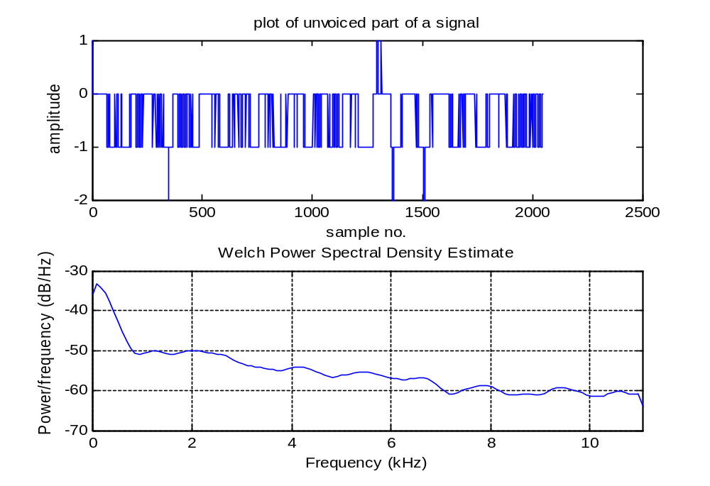
Figure 2.34 plot of signal and PSD estimate using Welch method
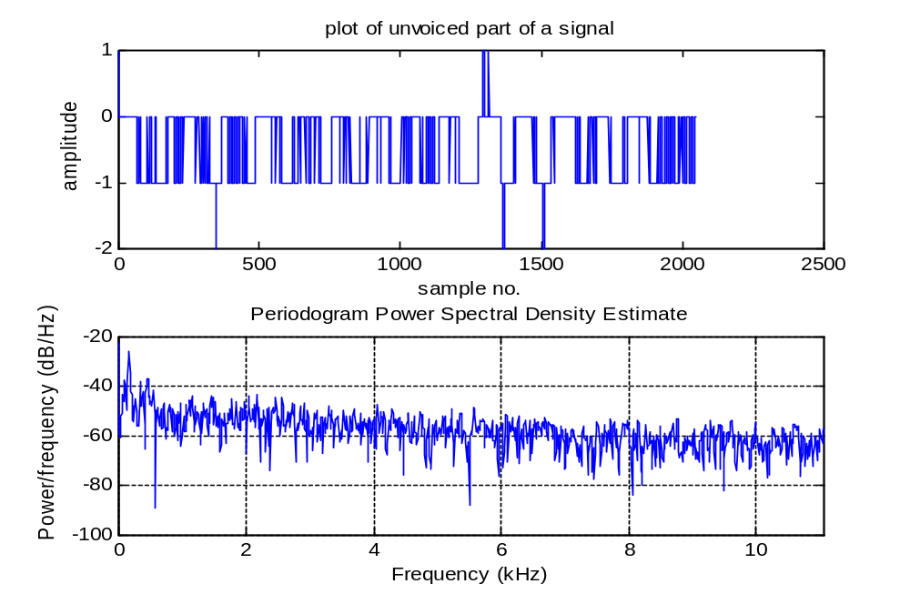
Figure 2.35 plot of signal and its PSD estimate using method of periodograms.

We see peaks in the PSD estimate using Welch method at 1200 Hz, 2000 Hz and 4000 Hz. The peaks using periodogram method are found to occur at 800 Hz, 1200 Hz, 1500 Hz, 2200 Hz etc. some of these peaks are lost using Welch method.

